Homework 1

Due: 11:59 PM on Wednesday, January 27, 2021.

Please answer in your own words and show any and all work.

1. (15 points) Consider a packet switching architecture:
   1. List and briefly describe the four main components of delay.

**Answer**: In Internet communication, to send a message from one end system to another end system, the source breaks the long message into a smaller chunk of data known as packets. As we know, that packet starts its journey from the source and finishes it on destination. Before reaching to destination, a packet suffers several types of delays at each node along the path. The four main components of delay are as following:

**Processing delay, queuing delay, transmission delay, and propagation delay**. If we accumulate all the four delay, we will get a nodal delay.

Let us dig a little bit more about each of these delays:

**Processing delay:**

Messages are divided into a chunk of data at the source end, which is called packets. Each packet has to go through from communication links and switches or routers before reaching the destination end system. Each packet consists of information of destination IP address in their header. The time required to analyze the packet’s header and determine the path to direct it for the next processing is in the part of processing delay. ‘The processing delay can also include other factors, “such as the time needed to check for bit-level errors in the packet that occurred in transmitting the packet’s bits from the upstream node to the router”[1]. In a high-speed router, the processing delay is typically on the order of microseconds.

**Queuing delay:**

The packet experiences a queuing delay at the queue ‘as it waits to be transmitted onto the link. For a specific packet to experience queueing delay, some important factors are the number of before arrived packets residing and waiting in queue for being transmitted onto the links. ‘Queuing delays can be on the order of microseconds to milliseconds in practice’ [1] depending upon the traffic onto links.

**Transmission delay:**

If we have a packet of length L and the transmission rate of a link from one router to another is R, the transmission delay can be represented as L/R. ‘Transmission delay is the amount of time required’ [1] to push all packet bits into the transmission link. Transmission delay is usually in micro to milliseconds.

**Propagation delay:**

Once the bit is pushed to link successfully, it must propagate to the next router to go along the path or reach the destination. The time required to propagate the packet from a source of the link to the destination router is known as Propagation delay. Speed of propagation depends on the link's physical medium, which lies between 2* 10^8 meters/sec to 3* 10^8 meters/sec. ‘In wide-area networks, propagation delays are on the order of milliseconds.’[1]

The formula for propagation delay is: The distance between two routers / Propagation speed.

* 1. Concisely describe what difference is between transmission and propagation delay.

**Answer:** Often, transmission and propagation delay are misunderstood or considered the same by all-new networking fields. The difference is minute but important. The transmission delay is measured as the time required by the router to push out the packet on the link; its important features are “the packet’s length and the link's transmission rate but has nothing to do with the distance between the two routers ” [1]. On the other side, the propagation delay is the time it takes all bits of the packet to propagate from one router to the next. The distance between the two routers is its important feature for identifying propagation delay, ‘but has nothing to do with the packet’s length or the transmission rate of the link’ [1].

As we know, before transmitting the packet on link whole packet needs to arrive as a switch. Suppose we have a packet of length 10Kb and the transmission rate on the link is 2Kbps. So, the transmission delay would be 5 sec for the packet. The time required to propagate the packet over the 100m link would be 3.333 e^ -7 is the propagation delay. ‘As propagation delay is directly dependent on distance, it can be negligible if the router is connected in the same university, but hundreds of milliseconds between satellite links. Similarly, transmission delay would be negligible for 10Mbps transmission rate on LAN, although it would be hundreds of milliseconds for Large internet packets sent over low-speed dial-up modem links’ [1].

* 1. How would the propagation delay be affected if the length of the packet is increased?

**Answer:** There will be no effect on propagation delay if the length of the packet is increased or decreased. As Propagation delay is not related to the packet length. Although if there is any change in the physical medium or link distance, the propagation delay will get affected directly. Since we know the propagation delay can be calculated as:

**dprop =** The distance between two routers

3*108

As we can see that there is no factor of packet length in the above formula of calculating propagation delay. Hence, we can say that there will be no effect on propagation delay even if the packet length increases.

1. (10 points) Suppose we have an application that transmits data continuously at a steady rate (e.g., *N*-bits are sent every *T* time units, where *T* is small and fixed) for a long time.
   1. Which network type would be more appropriate for this application: circuit-switched or packet-switched? Justify your answer.

**Answer****: Circuit Switch** would be more appropriate switching in this case. As in circuit switch, all the resources required, all the path is already reserved before even transmitting the packet. While packet switch resources are not reserved for communication or transmission, in fact, it works on the idea of utilizing the source on demand.

As specified in question that the application transmits data continuously with some steady rate for a long duration. Hence for transmitting, if we opt for packet switching, we know it will first check if the link is free to transmit the packet(data). If there is no other node sending data through the link, the link would be available for transmitting, but if there are some packets already in the queue from different hosts or applications, the packet must wait until the link is free. While circuit switch first establishes a connection between host and destination system, reserve all the resources such as buffers, links, and transmission rate for the transmission process. As it would be a dedicated connection between the source end system and destination end system routers and links, it will transfer the data with constant rate N/T bits. The connection is established specifically for this communication. The transmission will be fast compared to packet switches, where some other requests may hinder data transmission.

* 1. Now, consider a circuit-switched network that has a 150 Mbps link capacity where each user requires a bandwidth of 10 Mbps when transmitting, but are only active 10 percent of the time. What is the maximum number of users that can be supported? Justify your answer.

**Answer:** As specified in question the link capacity is 150Mbps

Individual user bandwidth required is 10Mbps

Although users are active only 10% of time but in circuit switching 10Mbps must reserve for individual user for all the time.

Thus, the user supported by circuit switch would be = 150Mbps/10Mbps

= 15

**So, the user supported is 15 by circuit switch network.**

1. (15 points) Consider a packet-switched network that has a 150 Mbps link capacity where each user requires a bandwidth of 10 Mbps when transmitting, but are only active 10 percent of the time. Also, assume that there are 29 packet switching users.
   1. Calculate the probability that exactly one user (i.e., any one of the 29 users) is transmitting at a given time, while the remaining are not. Using binomial distribution, show the formula for the calculation and the final result to 6 decimal places. Note that it may be easier to write a program to find the final value.

**Answer:**

As we know the formula for Binomial distribution is :

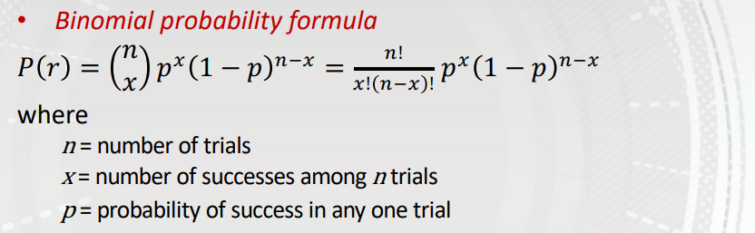

So for identifying the exactly user one to be active among 29 user can be determined by : P(1)

As mentioned in question user is active only 10 percent of time so being active probability is 0.1, so p=0.1 now we have n= 29 , x = 1. Lets calculate the probability.

**P(1) = exactly one user active is 0.151770**

Code Snapshot :

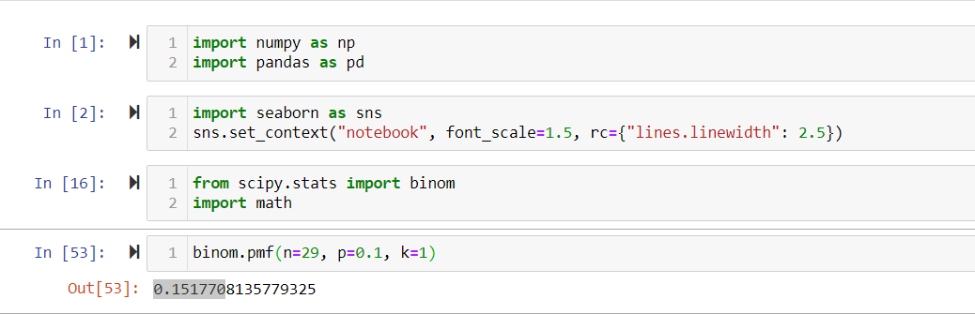

* 1. Now, calculate the summative probability that any up to 15 of the 29 users (i.e., 0, 1, 2, 3, …, 14, or 15 users) are transmitting at the same time, while the remaining users are not. Using binomial distribution, show the formula for the calculation and the final result to 6 decimal places. Note that it may be easier to write a program to find the final value.

**Answer:**

Just like above the probability of being active is 0.1(10/100). p = 0.1



For identifying upto 15 users active we need to calculate : P(0)+P(1)+P(2)+P(3)+ P(4)+P(5)+ P(6)+P(7)+ P(8)+P(9)+ P(10)+P(11)+ P(12)+P(13)+ P(14)+P(15).

n is same as above 29

x would be now 15

We have code to calculate the above binominal distribution:

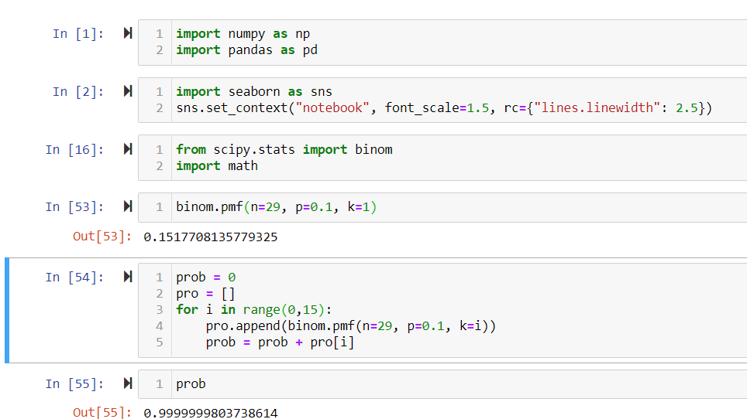

**So the probability is 0.999999 almost 1.0**

* 1. What is the probability to 6 decimal places that more than 15 of the 29 users are transmitting at the same time? What does this mean about the number of users supported under packet switching versus circuit switching for this scenario?

**Answer:**  For calculating number more than 15 users supported for packet switching. First we can identify the probability of 15 active user support on link, which we already did in above part of question i:e 3(b) and subtract it from 1.

Therefore the formula is:

Probability of more than 15 users = 1- Probability of maximum 15 user.

Probability of more than 15 users = 1- 0.999999(as calculated above)

Probability of more than 15 users = 0.000001 which is equivalent to 0 only

Now for packet switching the number of users supported is Link Capacity / User Bandwidth

= 150 Mbps/ 10 Mbps

= 15

Hence we can say that the maximum number of users supported by packet and circuit switch is same i:e 15 users.

1. (25 points) Consider the following network:

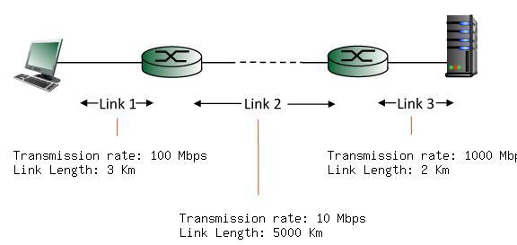

You may assume a packet length of 8000 bits and ignore queueing and processing delays. Use a propagation speed of in the following calculations.

* 1. Calculate the transmission and propagation delays on Link 1.

**Answer:**

Transmission delay = dtran1= Length of Packet / Transmission rate

Length of packet = 8000 bits = 8Kb

Link1 transmission rate = 100Mbps = 100000 Kbps

dtran 1= 8Kb/100000 Kbps = .00008 seconds

so the **transmission delay is 80 microsec**

Now lets calculate propagation delay which is represented as dprop1.

dprop 1= Link Length / propagation speed.

Link1 Length = 3 Km = 3000m

Propagation speed is =

dprop1 = 3000 m / = .00001 sec

**propagation delay is 10 microseconds**

* 1. Calculate the transmission and propagation delays on Link 2.

**Answer:**

Transmission delay = dtran 2= Length of Packet / Transmission rate

Length of packet = 8000 bits = 8Kb

Link 2 transmission rate = 10Mbps = 10000 Kbps

dtran2= 8Kb/10000 Kbps = .0008 seconds = 800microsec

so the **transmission delay is 0.8 millisec**

Now lets calculate propagation delay which is represented as dprop.2

dprop2= Link Length / propagation speed.

Link2 Length = 5000 Km = 5000000m

Propagation speed is =

dprop2 = 5000000 m / = 0.016666 sec = 16660 micro sec

**propagation delay is 16.66 millisec**

* 1. Calculate the transmission and propagation delays on Link 3.

**Answer:**

Length of packet = 8000 bits = 8Kb

Link 3 transmission rate = 1000Mbps = 1000000 Kbps

dtran3= 8Kb/1000000 Kbps = .000008 seconds

so the **transmission delay is 8 microsec**

Now lets calculate propagation delay which is represented as dprop.3

dprop3= Link Length / propagation speed.

Link3 Length = 2 Km = 2000m

Propagation speed is =

dprop3 = 2000 m / = 0.000006 sec

**propagation delay is 6 microsec**

* 1. Assuming the processing and queueing delays are negligible (i.e., 0), calculate the end-to-end delay from the left host (when begin transmitting first bit of a packet) to the right host (when the last bit of that packet is received).

**Answer:**

The end to end transmission is summation of processing, transmission, and propagation delay.

Since the processing and queuing delay are 0 at each link and node the total delay would be:

= dtran 1 + dprop 1+ dtran 2+ dprop 2+ dtran 3 + dprop 3

= 80 + 10 +800+16660+8+6

= 17564 microsec = 17.564 millisecond

* 1. For Link 1, determine the distance at which the transmission delay equals the propagation delay .

**Answer:**

To identify the distance for which the transmission delay will be equals to propagation delay, we assume at **d distance** its equal and rest values remain as it is .

So,

dprop1 = dtran1

8Kb / 100000Kbps = d /

8 * / 100000 = d

d = 24000m = 24 Km

Hence the distance at which propagation delay and transmission delay will be equal **is 24Km**

1. (15 points) Consider the following circuit-switched network where there are 4 links available between each router:

* 1. Determine the maximum number of simultaneous connections supported at any one time in this network.

**Answer:** As mentioned in question there are 4 links between each router.

So, simaltatinous connection between A and B cab 4 which will reserve 4 links.

Similarly, there will 4 connection between each immediate router such as B to C, C to D, and lastly A to D.

So, the maximum number of simultaneous connections supported on above circuit switch is 4+4+4+4 = 16

* 1. Suppose that users at the A router want to connect to end users at the C router. Determine the maximum number of simultaneous connections supported at any one time in this network for this scenario.

**Answer:**  For user to get connected from A to C, There are two options in for establishing the circuit switch i: e ABC and ADC.

Each router has four links available between them, so the maximum number of connections ABC router can support is 4 i: e from A to B suppose it will take link 1 from B to C it will choose link 2. This whole circuit will establish one link from A to C. Similarly, the other three links cab be established using remaining available links.

So, the connection supported simultaneously from ABC is 4.

And from ADC is also 4.

The total maximum number of connections simultaneously supported by the above network is 8.

* 1. Now, suppose that we have 4 users at the A router wanting to connect to end users at the C router and 4 users at the B router wanting to connect to end users at the D router. Is it possible to simultaneously make these 8 connections in this network? Justify your answer.

**Answer:**  No, it will not be possible to make above mentioned 8 connection at the same time.

So, let us say that 4 users at A occupy all the 4 links (maximum)from router A to B and then B to C in establishing a connection from A to C.

Now, if the user at router B wants to connect to a user at router D, he needs links from B to C, which has already been occupied/reserved for/by A to C connection. So, all the 4 users sitting at router B must wait until the previous circuit complete their processing of message transfer.

Once connection A to C is finished with transmission link will be free then only user at B can start reserving links for B to D user to connect. Now all the links users are waiting to establish a connection from B to D can reserve the 4 links from B to C and the C to D for completing their connection, which is the maximum number of links in between each router.

But they cannot make connection altoghter since there is common path in between both which B toC.

1. (5 points) Suppose that you have 200 terabytes (note that bytes, not bits, are used here) of data on a drive that you need delivered within 24 hours, but preferably faster. If your company has a dedicated 10 Gbps link available to transfer this data, would it be better to use FedEx overnight delivery (will be delivered in exactly 24 hours, but no earlier) or transmit the data on your dedicated link if these are your only options? Show calculations to justify your answer.

**Answer:**

Let’s first see if we transmit our data through dedicated link how much time will it take.

Total data needs to be send = 200 TB

= 200 * 8000 Gb = 1600000 Gb

Transmission rate dedicated for data transmission = 10Gbps

So the time required to transfer 200TB will be:

1600000 Gb / 10 Gbps = 160000 sec

Let’s convert 160000 sec to hours

1 hr = 3600sec

160000 sec = 44.44 hours

Since we need to transfer/deliver our data overnight (within 24 hours), and our system takes 44.44 hours, which is double of time asked in the question, we will use FedEx overnight delivery to transmit the 200TB drive.

**Hence FedEx delivery is right option.**

1. (10 points) Networked systems are organized into protocol layers.
   1. Briefly identify and describe two advantages of protocol layers.

**Answer:**  The two most important advantage of protocol layers are:

* It provides modularity, which provides an easy understanding of the system [2]. As explained in class, when the Airline system is separated into layers, it was easy to understand. Similarly, the same way can categorize the Internet into multiple layers in which each layer would have different functionality and have different protocols to follow so that it can provide services to the upper layers. Since the Internet is a complicated system consists of various applications, end systems, links, and packet switches. It would be easy to divide all these features and their protocols into different layers so that each layer will be responsible for their part of the work and take care of its functionality only. This gives another advantage that the working layer developer is not needed to know enhanced knowledge of other layers. If a developer is working in the Application layer, he only needs to know how to connect with the network layer, not the network layer's code and protocol details.
* Because of modularity, implementation simplicity, maintainability, flexibility, and scalability are easy to maintain [2].

As we know, the Internet system is divided into multiple layers. This protocol helps to achieve modularity, implementation simplicity, and more. We know that there five-layer internet protocol stack such as Application, Transport, Network, link, and physical. Suppose if there is any update in the application, we need to make the changes in application network protocol which will update their services which it provides to the user, but as we are changing application implementation, we do not need to be worried about the rest of the layer since each layer have different functionality or service which is independent of other.

* 1. Briefly identify and describe two disadvantages of protocol layers.

**Answer:**

The most common and important disadvantages are:

* Duplication of functionality leads to data overhead and processing.[2] Some of the functionality has been duplicated in more than one layer. One example of such is error recovery protocol, which is stacked on a per-link basis and end-to-end basis. This whole idea of duplicating the service of feature violates the very first advantage or rule of separating the functionality in layers.
* More layers are more the risk of breakdown.[2] If there are more layer, the chance of breakdown, corruption is high, since each layer is connected to one another for continuous service, if anyone of it breaks or bring down the whole service of internet. Also, identifying the problem in so much layer became intricate, and fixing it would be difficult and time-consuming.

1. (5 points) Suppose that you have a multiplexer (mux) with 5 different inputs at the following bit-rates: (A) 20 Kbps, (B) 8 Kbps, (C) 12 Kbps, (D) 8 Kbps, and (E) 4 Kbps. Using a fixed slot size in the frame, how would you organize a single asynchronous TDM link receiving the output of the mux to accommodate the varying data rates? That is, how many time slots are needed where, for example, a transmission with two slots per frame will arrive twice as quickly as one with one slot per frame? Draw a diagram of a single frame, labeling each slot appropriately.

**Answer:** In case of asynchronous TDM , individual slot in a frame is not dedicated to fix device. Individiual slot has index of device to receive data from. Even we can assign more than one input device in a frame .

Now we have 5 devices names A , B , C, D and E transmitting with different rate**.** Lets design a mux diagram which is taking input from these devices.

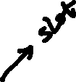

Each frame rate is of 12Kbps

Number of slot in a frame is 3

No of bits in a slot is 4Kb

Transmission rate of each circuit is : frame rate * no bits in a slot

= 12 * 4 = 48 Kbps.

Another could be:

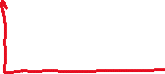

References:

[1]: Computer Networking: A Top-Down Approach featuring Internet 7th edition, Kurose and Ross, Addison Wesley,

[2]: https://www.researchgate.net/figure/ADVANTAGES-and-DRAWBACKS-of-LAYERED-APPROACH_tbl1_291075332